cat4 min read

Saint Lucia's 2022 National Awards recipients announced
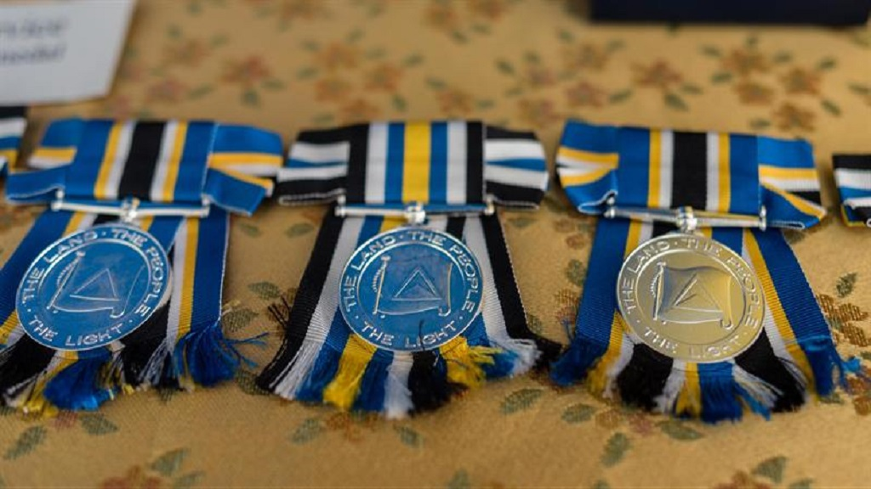
His Excellency the Acting Governor-General as Chancellor of the Order of Saint Lucia, on the advice of the Prime Minister, has been pleased to make the following appointments, to the Order of Saint Lucia in respect of Independence Day, 2022:
Knight Commander of the Order of Saint Lucia
Honourable George Theophilus (For exceptional and outstanding service of national importance to Saint Lucia)
Calixte George (For exceptional and outstanding service of national importance to Saint Lucia)
SAINT LUCIA CROSS
Dr Didacus Jules - For distinguished service in the field of Education, Public, Private and Civic Development, locally and regionally
Professor Hazel Simmons-Mc Donald - For distinguished service in the field of Education (Linguistics), locally and regionally
Luther Renaldo Francois - For distinguished service in the field of Arts and Culture (Music)
SAINT LUCIA MEDAL OF HONOUR (GOLD)
Dr Cato Thomas Laurencin - For eminent service rendered in the field of Medicine, Regenerative Engineering & Life Sciences internationally
Clarence Rambally - For eminent service in the field of Agriculture, National Development and Philanthropy
Lelia Harracksingh - For eminent service rendered in the field of Youth and Community Development, Public Health, Philanthropy
SAINT LUCIA MEDAL OF HONOUR (SILVER)
Dr Morella Joseph-Jn Baptiste - For eminent service rendered in the field of Education, administration research, (locally and regionally), and Community & Youth Development
Elizabeth Worrel St Ange - For eminent service rendered in the field of Education
Cassius Elias - For eminent service rendered in the field of Agriculture and Community Development
SAINT LUCIA MEDAL OF MERIT (GOLD)
Protus Auguste - For long and meritorious service in the field of Arts (Music)
John Cherubin - For long and meritorious service in the field of Arts and Culture
Richard Anthony Wayne Whitfield - For long and meritorious service in the field of Arts (Broadcasting).
SAINT LUCIA MEDAL OF MERIT (SILVER)
Esther Saltibus-Brice - For long and meritorious service in the field of Philanthropy and Community Development
Patricia Herman - For long and meritorious service in the field of Education and Community Development
SAINT LUCIA LES PITONS MEDAL (GOLD)
Thecla Deterville - For having performed long and meritorious service in the field of Business, Education and Sports (Netball)
Gilbert John Philippe Jn. Francois - For long and meritorious service in the field of Education and Youth Development
Heeves Renard - For long and meritorious service in the field of Community Development
SAINT LUCIA LES PITONS MEDAL (SILVER)
Francillia Monica Deterville - For having performed long and meritorious service in the field of Community Development and Philanthropy
Francis Suraj - For long and meritorious service in the field of Education
SAINT LUCIA LES PITONS MEDAL (BRONZE)
Mariana George - For having performed long and meritorious service in the field of Education and Community Development
Bernadette Sonny - For having performed long and meritorious service in the field of Education and Community Development
Felix Xavier - For having performed long and meritorious service in the promotion of public service and in the field of Community Development and Youth Development (Martial Arts)
NATIONAL SERVICE CROSS
Andre Collymore - For rendering loyal and devoted service beneficial to the Royal Saint Lucia Police Force, the Government and People of Saint Lucia
NATIONAL SERVICE MEDAL
Anseworth Aron Charlemagne - For outstanding and meritorious service to the Royal Saint Lucia Police Force, the Government and People of Saint Lucia
Lucius George Lake - For outstanding and meritorious service to the Royal Saint Lucia Police Force, the Government and People of Saint Lucia
Reuel Nathan Maynard Hyacinth - For outstanding and meritorious service to the Royal Saint Lucia Police Force, the Government and People of Saint Lucia
Elphege Williams - For outstanding and meritorious service to the Royal Saint Lucia Police Force, the Government, and People of Saint Lucia
THE PUBLIC SERVICES LONG SERVICE AWARD
His Excellency the Acting Governor-General has been pleased to award the Public Services Long Service Medal in respect of Independence Day, 2022 to the following persons:
St. Lucia Public Service
Victor Poyotte
Remise Anthony
St. Lucia Teaching Service
Norma Mary Bartlette Maynard
Catherine Jn. Baptiste
Royal Saint Lucia Police Force
Inspector of Police Lescenta Desir- Dolor
Superintendent of Police Patrick Scholar
Saint Lucia Air and Sea Ports Authority (Ports Police)
Corporal Rudy Auguste
Constable Anthony Solomon
Saint Lucia Fire & Emergency Services
Station Officer Elvin St. Juste
Assistant Divisional Officer Crescent Elgar George
Saint Lucia Prison Service (Bordelais Correctional Facility)
Correctional Officer II, Josephat Donat
Correctional Officer I, Pius Octave
Loop is better in the app. Customize your news feed, save articles for later, view your reading history and more. Click the links below to download the app for Android and IOS.

